Paws Abilities
Helping people enjoy their dogs.

“It’s all in how they’re raised.”
Posted on December 10, 2012
“All puppies are blank slates.” “If you do everything right with your puppy, you’ll have a great adult dog.” “If dogs have behavioral issues, we should blame the handle end of the leash.”
These are common misconceptions I hear as a trainer, and they make me so very sad. Behavior is a combination of nature and nurture, and if we could just take a moment to look logically at these myths, we would see just how silly they are.
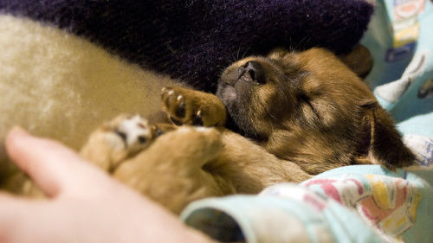
Genetics influence behavior. This is part of the reason we have breeds: if you want a dog to work your sheep, you’re going to choose a Border Collie, not a Brittany Spaniel. Even though the two dogs have the same basic size and shape, one is more likely to have the instinctive motor patterns to do the work than the other. Getting a Border Collie whose parents successfully work sheep further increases the likelihood of your dog having the necessary genetic ability to be a great sheepherder.
In the 1970′s, Murphree and colleagues began to study the difference between normal and fearful lines of Pointers. In cross-fostering experiments, puppies from fearful parents were raised by normal mothers. These puppies still turned out fearful, in spite of proper socialization and a confident role model.
Interestingly, puppies from normal parents who were raised by fearful mothers also turned out fearful. Environment also influences behavior, and the best genetics in the world can’t create the perfect dog without a supportive upbringing.
If we believe that the way a dog is raised is solely responsible for his adult behavior, how can the tremendous success of the Pit Bulls from Michael Vick’s kennel and many other fighting operations be explained? With their neglectful and abusive upbringing, we would expect these dogs to be vicious and unsalvageable. Yet many of them have gone on to become wonderful pets. Some compete in agility or work as certified therapy dogs. Many Pit Bull enthusiasts are adamant that it’s all in how the dogs are raised, yet the success of many former fighting dogs tells us that it’s more than just that. These amazing, resilient dogs also have to have a sound genetic basis to explain their ability to overcome adversity.
On the other end of the spectrum, many of my clients have done everything right, yet continue to struggle with anxiety or aggression issues in their dogs. Certain lines of Golden Retrievers are known for severe resource guarding issues that often show up even in tiny puppies. Most of my German Shepherd behavioral consults occur when these dogs hit 12-18 months and growl at or bite a stranger. Miniature Australian Shepherds are likely to come to me due to extreme fear issues at 6-10 months of age. Terrier owners often call me when their dog hits social maturity and begins fighting with housemate dogs. While these traits may be common in my area, trainers in other areas of the country report completely different issues in the same breeds due to different lines of dogs with different genetic potentials living and being bred near them. I also see hundreds of friendly, stable, solid Goldens, German Shepherds, mini Aussies, and terriers in our Beginning Obedience and Puppy Kindergarten classes.
The truth is that dogs are born with a certain genetic potential that will influence which behavioral traits they display. This could include a dog’s sociability towards people, dogs, or other animals; their level of boldness or fearfulness; their likelihood to display anxious or compulsive behaviors; whether they are calm and confident or nervous and neurotic; and many other behavioral factors.
Let’s look at one trait to make this more clear. We know that dogs born from fearful parents are more likely to be fearful and that dogs with bold parents are more likely to be bold. There is a behavioral continuum, with boldness on one end and fearfulness on the other. Here’s what that spectrum would look like. A dog on the left end of the spectrum would be incredibly fearful, while a dog on the right end would be exceedingly confident. Most dogs wind up somewhere in the middle, and dogs on both ends of the spectrum present challenges for their owners.
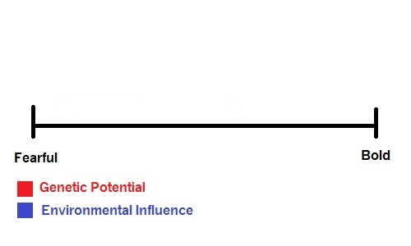
A dog with bold parents is born with the potential to be quite bold. He is physically capable of bold behavior. However, that doesn’t necessarily mean that he will become a bold dog. If his experiences as a puppy and young adult are very limited or if he has negative, scary experiences, he may develop into a fearful adult due to environmental influence. His genetic potential gave him the ability to be bold, but his environment did not nurture that ability.
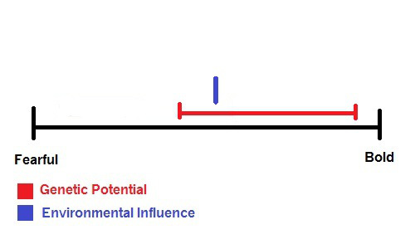
On the other hand, consider a dog who is born from fearful parents. This dog does not have the genetic potential to be bold. Even given an incredibly supportive and nurturing environment as a puppy and young adult, this dog will always be somewhat fearful because the physical ability to be bold is just not there.
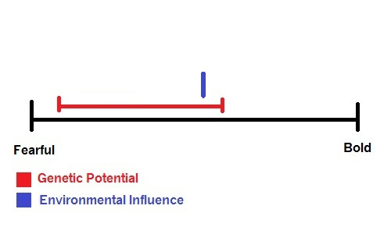
These dogs may present identically when we look at their behavior, in spite of the very different levels of dedication their owners had to socializing and supporting their puppies. However, the genetically bold dog may make a lot of progress with appropriate behavioral interventions, while the genetically fearful dog makes little or none. This has nothing to do with the skill level of each dog’s owner, but rather with the raw material each dog started with. (This is also, by the way, why ethical trainers do not make guarantees: without knowing what genetic package a dog starts with, there’s no way to know how much progress that dog can make until we try.)
Do you see how very unfair statements about how “it’s all in how they’re raised” are to committed, wonderful dog owners who have dogs with more difficult baselines? Just because your dog flew through a behavior mod program doesn’t mean every dog can or will, and assuming that it’s all because of the owner is unrealistic and downright cruel. I regularly work with wonderful people who do the best they can with difficult dogs, and that adage about walking a mile in someone’s shoes is applicable to their situation. As if living with and training a more difficult dog weren’t enough, these people are often subjected to comments and insinuations that if they were just a better handler, a better trainer, or a better leader, their dog would be perfectly fine. This is untrue and incredibly hurtful, and it needs to stop.

